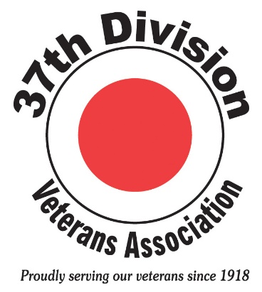

The 37th Division Veterans Association (37th DVA), a non-profit organization, was originally formed in 1918 by veterans of the 37th Infantry Division who fought in Europe during WWI. It was formed to honor veterans who gave their lives while serving our nation and to help the dependents of these heroic soldiers. That mission continues today as we strive to support heritage units of the 37th ID currently serving in the Ohio National Guard including the 37th Infantry Bridge Combat Team who wears our insignia.

Each year the association holds an annual reunion at Camp Perry in Port Clinton, Ohio. This reunion along with providing camaraderie and information is an entertaining way to keep current with members of the association. We’ll celebrated our 100th birthday at the reunion held August 24-25, 2018.

We assist members and non-members in obtaining DD-214 separation forms as well as in obtaining certificates of service on record and in requesting individual administrative and medical records from the records center in St. Louis, Missouri. We also facilitate scheduling of funeral Honor Guard details.

We assist veterans in securing medals earned, but not awarded, such as numerous Bronze Star Conversion awards for those earning the CIB or CMB in infantry units during WWII.

We manage a portfolio of investments from which we award scholarship grants annually to members and descendants of our veterans. Since 2000, 194 grants have been awarded totaling $87,650.00.

We publish a newsletter three times per year, the 37th Division Veterans News.

If you served in the 37th Infantry Division, have served or are serving in a heritage unit of the 37th Infantry Division with the Ohio Army National Guard, or are a spouse/widower, descendant or parent of someone who did or does, you are eligible to join the 37th DVA. If you do not meet one of the above, you can become an Associate Member of the organization.

Annual memberships cost $20.00 for emailed copies of the newsletter or $30.00 for mailed copies of the newsletter.

We welcome your membership to our 100-year-old association. For more information, please visit us at www.37thdva.org.

