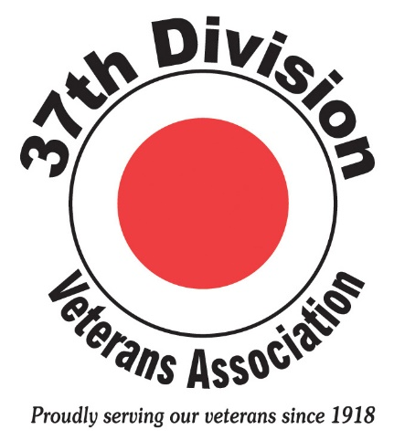

Dear Scholarship Grant Recipient, February 2017

As the 37th Division Veterans Association (37th DVA) looks forward to celebrating its 100th anniversary in 2018, we wanted to reach out to our scholarship grant recipients to find out how you are doing. It is our hope that our grant program assisted you in accomplishing your academic and career goals.

To that end, we invite you to write an article for our newsletter highlighting how receiving a grant impacted you. Article content is up to you. Feel free to include things like:

- How is the veteran that sponsored your grant application doing?

- What does their military service mean to you as an adult?

- Why did you choose your current profession and how are you utilizing your education?

- What was one of your most defining moments in life thus far?

You are one of 183 grant awardees that have received a grand total of $81,550.00 in scholarship funding. Nearly 100 of our members have sponsored one or more of their offspring for this program. We look forward to highlighting your success and sharing it with our members.

Stories can be emailed to me at mandy@37thdva.org. Sponsors are encouraged to share their input as well so feel free to include their sentiment in your article. Grant recipients will be contacted if their story is selected for publication.

As a descendent of a 37th DVA member, you are eligible to become a member of the association. We hope that you will help us celebrate our century anniversary by joining our ranks. Please refer to the “MEMBERSHIP” tab on our website to view the membership application and for more details.

We look forward to hearing from you and wish you continued success.

Sincerely,

Mandy Oberyszyn
37th DVA Executive Director

