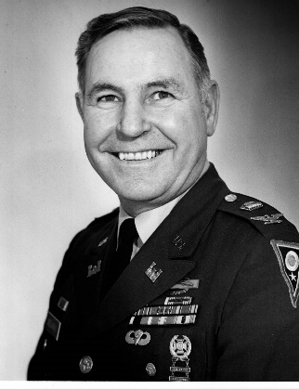

COL (Ret) Cyril “Cy” Lawrence Sedlacko, a Columbus resident, passed away peacefully on July 10, 2019. He was born in Campbell, Ohio, on July 3, 1924, the sixth of nine children born to the late Michael and Anna (Melek) Sedlacko who immigrated from what is now Slovakia.

He is survived by his loving wife of 50 years, Jacqueline (Bingham) Sedlacko, two daughters, Mandy (Andy) Oberyszyn and Molly (Chris) Woodruff, his honorary daughter Dr. Tania Oberyszyn, and grandchildren, Evan and Alex Oberyszyn and Dylan Woodruff, who were the light of his life. He is also survived by his dear brother Victor (Lee) Sedlacko, and sister Agnes (the late Paul) Lisko, as well as several generations of nieces and nephews.

He is preceded in death by his son, John Sedlacko, grandsons Rohan and Isaac Woodruff, and five siblings.

After graduating from Scienceville High School, he joined the U.S. Army in 1943. During WWII, he was a paratrooper with 17th Airborne Division. He fought in the Battle of the Bulge and later parachuted in to Wesel, Germany. He was honorably discharged in December 1945 having earned the Legion of Merit, the Bronze Star and the Purple Heart among other awards.

After the war he worked at Truscon Steel in Youngstown. He began his 30-year career with the Ohio National Guard in 1949. He retired from the guard in 1979 as the state Recruiting and Retention Officer having earned the rank of colonel. Although he held numerous positions, his assignment as Battery Commander of Charlie Battery, 135th F.A., was the most enjoyable period of his military service.

After retiring from military service, he worked for the Ohio Department of Commerce including time as the Deputy Chief of the Division of Licensing followed by time as the administrative assistant to Ohio’s Division of State Fire Marshall. His career with the state spanned 13 years.

Never one to be idle, he became involved with the 37th Division Veterans Association (37th DVA) where he held numerous positions including President and its first Secretary/Treasurer; a position he held for 17 years resigning in 2018 when he was 94. His tireless efforts helped the association celebrate its 100th year of service to veterans in August 2018. During the 37th DVA’s centennial celebration, he was surprised by being honored with the inaugural “Cy Sedlacko Award of Excellence” which will be awarded annually to an association member displaying the level of dedication he did. He was also recognized for his work with veterans and the 37th DVA in 2009 by being inducted into the Ohio Veterans Hall of Fame. He holds life memberships in numerous veterans organizations including the American Legion, MOAA, ONGA and the VFW.

He enjoyed bowling and golfing with friends and family. Blackhawk and Dogwood Golf Courses were favorites. Memories of his big grin and the many tag lines he liked to use will bring joy to those who loved him; in his memory it seems fitting to say goodbye to Cy by using one of his best, “I love you so much it hurts.”

Visitation will be held on Monday, July 15, 2019, at the Schoedinger Worthington Chapel 6699 N. High St., Worthington, OH, 43085, from 4-7 PM. Visitation will also be from 10-11 AM on Tuesday at St. Joan of Arc Catholic Church, 10700 Liberty Rd., Powell, OH, 43065, where a funeral service will follow at 11 AM. In lieu of flowers, donations can be made to the 37th DVA, www.37thdva.org, and the March of Dimes, https://www.marchofdimes.org/giving/support-general.aspx.

